Placement Management Platform

MU Praktikak is the application of Mondragon Unibertsitatea for managing the different learning activities in the Dual programme.
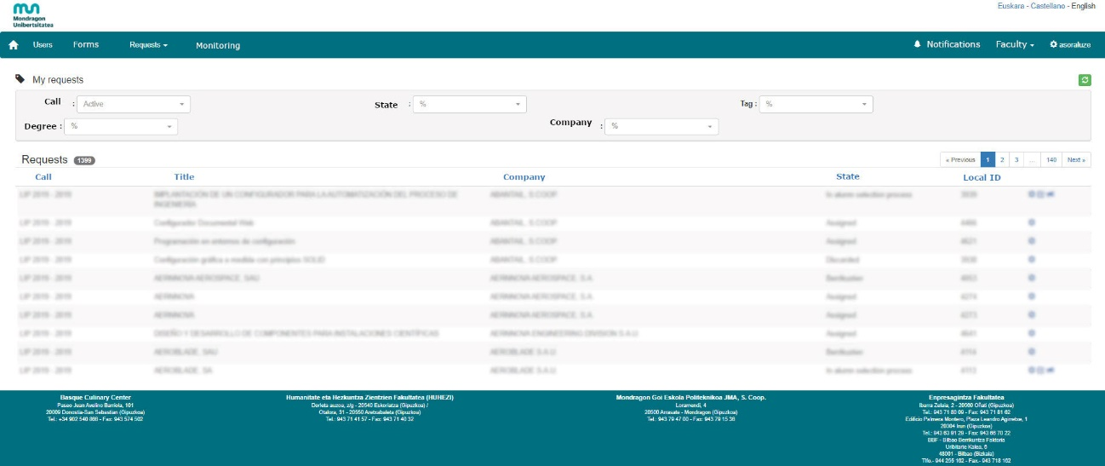

Figure 1: MU Praktikak – Dual programme management platform

The groups who have access to the application are:
- Students
- MU Dual degree coordinators
- Company HR managers
- Company tutors
- MU tutors
- Academic services and Dual Programme coordinator

The functionalities available according to the group are the following:
Students
Students request to participate in the Dual training programme. They complete the application form uploading the following information: CV, degree and academic year, languages, geographical preferences, field of interest, car availability.
Students view companies' offers and select the ones they are interested in.

Dual degree coordinators
The Dual degree coordinator ensures that the training project described by the company fits the profile of the degree and has been completed correctly. Otherwise, it initiates a process of coordination with the company to complete the necessary information.
They manage and follow up on company requests for their degree. The Dual degree coordinators encourage and support the students interested in a company offer.

Company HR department managers
Companies interested in joining the Dual programme must make the request through this application and upload information regarding:
- Administrative data of the company.
- Duration of the apprenticeship, company contact (HR), tutor.
- Learning agreement type (university company agreement/work contract).
- Learning project (description/framework, objectives and phases).
- Comments (associated with necessary profile requirements).
The company receives CVs of interested students that match the request made. They can follow the state and evolution of their requests.
The HR department receives partial and final assessment information of the apprentices in their company.

Company tutors
Transversal and technical competences that the student will work on are defined between the company and the academic tutor.
The assessment system included in the application is in line with the development of these competences (technical and transversal competences) and is coordinated by the university and company tutors.
The questionnaire contains items such as technical and learning abilities, task management, communication skills, responsibility, adaptation, initiative, motivation, teamwork, etc.
Company tutors can access their students’ partial or global assessment information.

Academic tutors
Transversal and technical competences that the student will work on are defined between the company and the academic tutor and uploaded on the platform. These learning objectives are defined considering the evolution of the learning process in terms of complexity, quality and autonomy during the apprenticeship.
The assessment system included in the application is in line with the development of these competences (technical and transversal competences) and is coordinated by the university and company tutors.
The tutor fills in the following application information:
- follow-up meeting information
- activities table and evolution plan of the learning process
- transversal and technical competences
- the assessment of the student

Academic services and Dual programme coordinator
Academic services manage and publish the different calls of the apprenticeship programme on the platform and follow up the state of company requests and processes of selection of apprentices.
This coordination manages and monitors the apprenticeship processes:
- maintaining and updating the database
- history of apprentices assigned to companies
- learning agreement information
- follow up the state of the learning process and information
- registers in the EST (European Supplement to the Title)

